**Suggested items to go rock hounding**

**Basic Desert Gear (be safe don’t underestimate)**

* 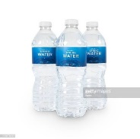**Drinking WATER:** Dehydration can really ruin your rocking hounding experience and send you to the hospital.
* **First Aid kit:** basic kit is fine.
* **Medication:** prescription and over-the-counter (aspirin, Tylenol, etc)
* 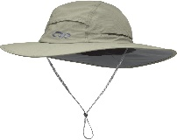**Trail Food:** nuts, snacks, fruit
* **Long Sleeves**
* **Sun hat**
* **Sunscreen**
* **Sturdy walking shoes/hiking boots**: Collecting areas generally have rough footing. Ankle support is best.

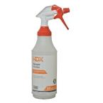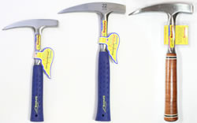**Basic Rockhounding Gear**

* **Gloves:** Leather is the best.
* **Eye protection:** Protect against flying rock chips when hammering.
* **Collecting Bags and/or Buckets**
* **Spray bottle with water.** Additional waterto refill bottles and/or drink in needed.
* 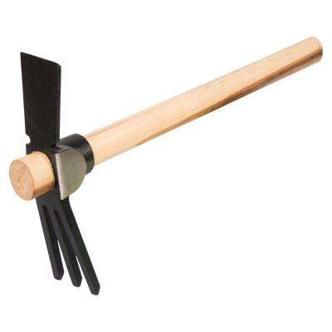**Rock pick**
* **Hoe pick**
* 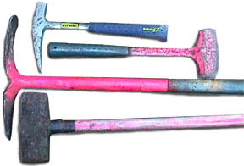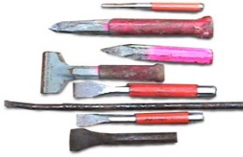**Trowel**

**Additional/Advanced Tools**

* **Gads**
* **Sledge hammer**.
* **Shovel**
* **Snake guards**: you can find these at hunting supply stores
* **Crowbar or pry bar**: A basic tool every rock hound should have. 22" pry bars are good basic tools, although 30" and larger are needed for really heavy work.

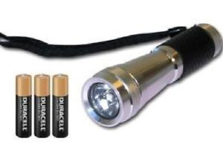**You can’t be too carful**

* **More water**
* 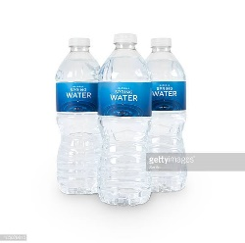**Cell phone**
* **GPS**
* 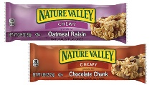**Flashlight & batteries**
* **Food**
* **Extra clothes**
* **Day pack**